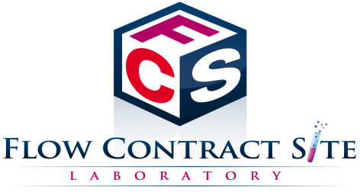
Hello FCS Laboratory Friends and Colleagues,

Flow Contract Site (FCS) Laboratory would like to give you a brief introduction to our company and highlight the services we offer to meet your needs. We look forward to hearing from you very soon!

Leaders in Flow Cytometry Testing for Drug Development
FCS Laboratory operates as a contract research organization (CRO) with its main offering of flow cytometry-based assays for nonclinical and clinical drug development. With 7+ years in business, we strive to collaborate with our clients, respond to our customers' evolving needs, anticipate regulatory change, invest in our facilities and our people, and seek to assert ourselves at the forefront of the field of flow cytometry. This is achieved through:
- Scientist-to-scientist consultations for flow cytometry assay/protocol development and analysis
- Working with academic institutions, biotech/pharma companies, and CROs
- Serving all drug development stages from R&D, nonclinical testing, and on into clinical trials
- Offering competitive pricing based on study specifics
Our Instruments are Among the Finest in the Industry
FCS Laboratory has the equipment and the expertise already, so you don't need to acquire them yourself. Instruments that we own are:
- One BD FACSCanto™ A system with two scatter parameters and up to 6 fluorescent channels
- Three BD FACSCanto™ II systems with two scatter parameters and up to 8 fluorescent channels
- Two Millipore Guava PCA systems for cell count and viability testing
We are proficient in processing a multitude of specimen types including human, non-human primate, mice, other animal models, whole blood, PBMCs, bone marrow, spleen, tumors, cell lines, etc.

Flow Contract Site Laboratory Testing, Assays, Research and Development Services Include*:
- Immunophenotyping
- Intracellular Protein Analysis (Tregs, phosphoproteins, cytokines, etc.)
- Cellular Functional Analysis (NK Functional Assay, Basophil Activation Test (BAT))
- Receptor Occupancy
- Cell Cycle, Apoptosis, Viability
Get Results
- First-rate and personal customer service with frequent project updates
- State-of-the-art facilities and equipment
- Prompt, clear, comprehensive, and accurate reporting
- Turnaround time unequaled by other contract laboratories; in certain cases 3-5 days
- Upfront itemized pricing with no hidden costs
- Expertise in client processes, eliminating turnover issues
Contact Us
Please follow the link below to our website where you can contact us and submit a request for a quote. We are very excited to service your flow cytometry needs and look forward to building a strong working relationship with you!

* FCS Laboratory offers both GLP and non-GLP contract flow cytometry services.

